**ABSTRACT**

IPL Database Management is a cricket scheduling-based application exclusively for the game of cricket. The Application features schedules, information about teams, records of batting and bowling, creating new schedules, can search about players, it displays rank tables for teams and players. The admin has all authorities to make changes for the database so admin can add players, can add schedules, can add stadiums and also have permission to removing of them from the database. It features with searching of players involved in the game and retrieve the players of the particular match by selecting match number. Also, can fetch the schedules with their venue and squad available by the team, players selected for the current match. Admin can also authority to update the rating of the teams and also players runs and wickets and other match particulars in this database.

The user’s login window also featured with create an account, player search for players information, getting future match particulars, rankings, cricket boards, stadiums, schedules and their venues. Can fetch the schedules with their venue and squad available by the team, players selected for the current match.

**TABLE OF CONTENTS**

Acknowledgement (i)

Abstract (ii)

Table of contents (iii)

1 Introduction1

1.1 Introduction to database management system1

1.2 History of DBMS2

1.3 Applications of DBMS3

1.4 Overview of the project………………………………………………………………3

1.5 Theory and Concepts4

1.6 xampp server4

2 Requirements Specification5

2.1 Specific Requirements5

2.1.1 Hardware Requirements 5

2.1.2 Software Requirements 5

2.2 About Technologies Used6

3 System Design8

3.1 Input Design8

3.1.1 Admin8

3.1.2 User8

3.2 Database design8

3.3 Relational schema9

3.4 ER Diagram10

3.5 Output design12

4 System Implementation13

4.1 Implementation13

4.2 Create connection to database13

4.3 Closing a connection13

4.4 Triggers and stored Procedures14

4.4.1 Stored Procedure14

4.4.2 Trigger15

4.5 Result15

5 Snapshots16

Conclusion28

Future Enhancements

References

**CHAPTER 1**

**INTRODUCTION**

**1.1 INTRODUCTION TO DATABASE MANAGEMENT SYSTEM**

Databases and database technology have a major impact on the growing use of computers. It is fair to say that databases play a critical role in almost all areas where computers are used, including business, electronic commerce, engineering, medicine, genetics, law, education, and library science. The word database is so commonly used that User must begin by defining what a database is. Our initial definition is quite general. A database is a collection of related data.1 By data, User mean known facts that can be recorded and that have implicit meaning. For example, consider the names, telephone numbers, and addresses of the people you know. You may have recorded this data in an indexed address book or you may have stored it on a hard drive, using a personal computer and software such as Microsoft Access or Excel. This collection of related data with an implicit meaning is a database. The preceding definition of database is quite general; for example, User may consider the collection of words that make up this page of text to be related data and hence to constitute a database. However, the common use of the term database is usually more restricted.

A database has the following implicit properties:

* A database represents some aspect of the real world, sometimes called the mini world or the universe of discourse. Changes to the inworld are reflected in the database.
* A database is a logically coherent collection of data with some inherent meaning. A random assortment of data cannot correctly be referred to as a database
* A database is designed, built, and populated with data for a specific purpose. It has an intended. group of users and some preconceived applications in which these users are interested.

A database management system (DBMS) is a collection of programs that enables users to create and maintain a database. The DBMS is a general-purpose software system that facilitates the processes of defining, constructing, manipulating, and sharing databases among various users and applications. Defining a database involves specifying the data types, structures, and constraints of the data to be stored in the database. The database definition or descriptive information is also stored by the DBMS in the form of a database catalogue or dictionary; it is called meta-data. Constructing the database is the process of storing the data on some storage medium that is controlled by the DBMS. Manipulating a database includes functions such as querying the database to retrieve specific data, updating the database to reflect changes in the inworld, and generating reports from the data. Sharing a database allows multiple users and programs to access the database simultaneously.

**1.2 History of DBMS**

In 1959, the TX-2 computer was developed at MIT's Lincoln Laboratory. The TX-2 integrated a number of new man-machine interfaces. A light pen could be used to draw sketches on the computer using Ivan Sutherland's revolutionary Sketchpad software. Using a light pen, Sketchpad allowed one to draw simple shapes on the computer screen, save them and even recall them later. The light pen itself had a small photoelectric cell in its tip. This cell emitted an electronic pulse whenever it was placed in front of a computer screen and the screen's electron gun fired directly at it. By simply timing the electronic pulse with the current location of the electron gun, it was easy to pinpoint exactly where the pen was on the screen at any given moment. Once that was determined, the computer could then draw a cursor at that location. Also, in 1961 another student at MIT, Steve Russell, created the first video game, E. E. Zajac, a scientist at Bell Telephone Laboratory (BTL), created a film called "Simulation of a two-gravity attitude control system" in 1963. During 1970s, the first major advance in 3D computer graphics was created at UU by these early pioneers, the hidden-surface algorithm. In order to draw a representation of a 3D object on the screen, the computer must determine which surfaces are "behind" the object from the viewer's perspective, and thus should be "hidden" when the computer creates (or renders) the image. In the 1980s, artists and graphic designers began to see the personal computer, particularly the Commodore Amiga and Macintosh, as a serious design tool, one that could save time and draw more accurately than other methods. In the late 1980s, SGI computers were used to create some of the first fully computer-generated short films at Pixar. The Macintosh remains a highly popular tool for computer graphics among graphic design studios and businesses. Modern computers, dating from the 1980s often use graphical user interfaces (GUI) to present data and information with symbols, icons and pictures, rather than text. Graphics are one of the five key elements of multimedia technology. 3D graphics became more popular in the 1990s in gaming, multimedia and animation. In 1996, Quake, one of the first fully 3D games, was released. In 1995, Toy Story, the first full-length computer-generated animation film, was released in cinemas worldwide. Since then, computer graphics have only become more detailed and realistic, due to more powerful graphics hardware and 3D modeling software.

**1.3 APPLICATIONS OF DBMS**

Applications where we use Database Management Systems are:

**Telecom**: There is a database to keeps track of the information regarding calls made, network usage, customer details etc. Without the database systems it is hard to maintain that huge amount of data that keeps updating every millisecond.

**Industry**: Where it is a manufacturing unit, warehouse or distribution Centre, each one needs a database to keep the records of ins and outs. For example, distribution Centre should keep a track of the product units that supplied into the Centre as well as the products that got delivered out from the distribution Centre on each day; this is where DBMS comes into picture.

**Banking System**: For storing customer info, tracking day to day credit and debit transactions, generating bank statements etc. All this work has been done with the help of Database management systems.

**Education sector**: Database systems are frequently used in schools and colleges to store and retrieve the data regarding student details, staff details, course details, exam details, payroll data, attendance details, fees detail etc. There is a hell lot amount of inter-related data that needs to be stored and retrieved in an efficient manner.

**Online shopping**: You must be aware of the online shopping websites such as Amazon, Flipkart etc. These sites store the product information, your addresses and preferences, credit details and provide you the relevant list of products based on your query. All this involves a Database management system.

**1.4 Overview of the project**

IPL Database Management is a user-friendly Application which is based on HTML and CSS which helps members to schedule and manage various Cricket Matches and also allows us to manage the records of various players. The application uses HTML and CSS as a front end for interacting with the user and PHP for connection. At backend we used MySQL for database.

**1.5 Theory and Concepts**

**Inheritance**: In object-oriented programming, inheritance is when an object or class is based on another object or class, using the same implementation (inheriting from an object or class) or specifying a new implementation to maintain the same behavior (realizing an interface). Such an inherited class is called a subclass of its parent class or super class.

**Encapsulation**: In object-oriented programming, encapsulation is a mechanism of binding the data, and the functions together in a class and use them by creating an object of that class.

**Data Abstraction**: Data abstraction refers to, providing only essential information to the outside world and hiding their background details, i.e., to represent the needed information in program without presenting the implementation details. Data abstraction is a programming (and design) technique that relies on the separation of interface and implementation.

**1.6 Xampp server**

XAMPP is a free and open source cross platform web server solution stack package developed by Apache Friends, consisting mainly of the Apache HTTP Server, Maria DB database, and interpreters for scripts written in the PHP and Perl programming languages. XAMPP stands for Cross-Platform, Apache, Maria DB, PHP and Perl. It is a simple, lightweight Apache distribution that makes it extremely easy for developers to create a local web server for testing and deployment purposes. Since most actual web server deployments use the same components as XAMPP, it makes transitioning from a local test server to a live server extremely easy as well.

**Chapter 2**

**Requirements Specification**

**2.1 Specific Requirements**

The specific requirements of the IPL Database Management are stated as follows:

**2.1.1 Hardware Requirement**

The section of hardware configuration is an important task related to the software development insufficient random-access memory may affect adversely on the speed and efficiency of the entire system. The process should be powerful to handle the entire operations. The hard disk should have sufficient capacity to store the file and application

Processor : Intel PentiumT4200/ Intel Core Duo 2.0 GHz / more

RAM : Minimum 1 GB RAM capacity

Hard disk : Minimum 40 GB ROM capacity

Cache Memory : L2-1 MB

GPU : Intel HD Graphics

**2.1.2 Software Requirement**

A major element in building a system is the section of compatible software since the software in the market is experiencing in geometric progression. Selected software should be acceptable by the firm and one user as well as it should be feasible for the system.

This document gives a detailed description of the software requirement specification. The study of requirement specification is focused specially on the functioning of the system. It allows the developer or analyst to understand the system, function to be carried out the performance level to be obtained and corresponding interfaces to be established.

Front End : PHP (Hypertext preprocessor)

Back End : XAMPP server, My SQL

Operation System : Windows 7 Or Windows 8.1 Or Windows 10

Client side : CSS (cascading Style sheet)

**2.2 About Technologies used**

* **HTML** is integrated in **PHP**. It provides a means to structure text-based information in a document. It allows users to produce web pages that include text, graphics and hyperlinks.
* **CSS (**Cascading Style Sheets) is a style sheet language used for describing the presentation of a document written in a mark-up language. Although most often used to set the visual style of web pages and user interfaces written in HTML and XHTML, the language can be applied to any XML document.
* **MYSQL** is the language used to manipulate relational databases. It is tied closely with the relational model. It is issued for the purpose of data definition and data manipulation. Program runs as a server providing multi-user access to a number of databases. MySQL is a multithreaded, multi-user SQL database management system (DBMS). It includes facilities to add, modify or delete data from the database, ask questions (or queries) about the data stored in the database and produce reports summarizing selected contents.
* **PHP** is a scripting language originally designed for producing dynamic web pages. It has evolved toinclude a command line interface capability and can be used in standalone graphical applications. PHP is a general-purpose scripting language that is especially suited for web development. PHP generally runs on a web server, taking PHP code as its input and creating web pages as output. It can also be used for command-line scripting and client-side GUI applications. PHP can be deployed on most web servers, many operating systems and platforms, and can be used with many relational database management systems. It is available free of charge, and the PHP Group provides the complete source code for users to build, customize and extend for their own use. PHP stores whole numbers in a platform-dependent range. This range is typically that of 32-bit signed integers. PHP has hundreds of base functions and thousands more from extensions. These functions are well documented on the PHP site. It requires MySQL connection between the front end and back end components to write to the database and fetch required data.

**Chapter 3**

**SYSTEM DESIGN**

**3.1 Input Design**

The Home page contains two buttons for Admin and User section.

**3.1.1 Admin**

The Admin can do different functions with help of two navigation bars one at top and one at bottom

* can Add and Delete Players.
* can Add and Delete Stadiums.
* can Add and Delete Schedules.
* can also search for player information.
* can view Stadiums, Rankings, Cricket Boards.
* can fetch the schedules with their venue and squad available by the team, players selected for the current match.
* can view players who got selected for match.
* can also update team and players rankings.
* can search for players in a particular match.

**3.1.2 User Information**

After admin logins into the database and adds information, user can fetch that it is as follow. It contains one navigation bar that contains

* can also search for player information.
* can view Stadiums, Rankings, Cricket Boards.
* can fetch the schedules with their venue and squad available by the team, players selected for the current match.

**3.2 Database design**

The data in the system has to be stored and retrieved from database. Designing the database is part of system design.

Data elements and data structures to be stored have been identified at analysis stage. They are structured and put together to design the data storage and retrieval system. A database is a collection of interrelated data stored with minimum redundancy to serve many users quickly and efficiently. The general objective is to make database access easy, quick, inexpensive and flexible for the user. Relationships are established between the data items and unnecessary data items are removed. Normalization is done to get an internal consistency of data and to have minimum redundancy and maximum stability. This ensures minimizing data storage required, minimizing chances of data inconsistencies and optimizing for updates. The MS Access database has been chosen for developing the relevant databases.

**3.3 Relational Schema**

The term "schema" refers to the organization of data as a blueprint of how the database is constructed (divided into database tables in the case of relational databases). The formal definition of a database schema is a set of formulas (sentences) called integrity constraints imposed on a database. A relational schema shows references among fields in the database. When a primary key is referenced in another table in the database, it is called a foreign key. This is denoted by an arrow with the head pointing at the referenced key attribute. A schema diagram helps organize values in the database. It also gives an idea of what order the tables should be created in. The following diagram shows the schema diagram for the database.

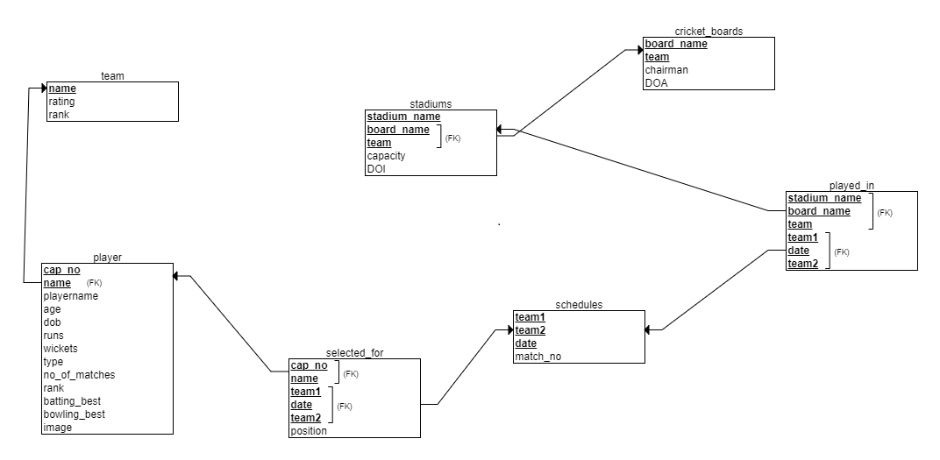

Figure 3.1: Relational schema

**3.4 ER Diagram**

An entity–relationship model is usually the result of systematic analysis to define and describe what is important to processes in an area of a business. An E-R model does not define the business processes; it only presents a business data schema in graphical form. It is usually drawn in a graphical form as boxes (entities) that are connected by lines (relationships) which express the associations and dependencies between entities. An ER model can also be expressed in a verbal form, for example: one building may be divided into zero or more apartments, but one apartment can only be located in one building. Entities may be characterized not only by relationships, but also by additional properties (attributes), which include identifiers called "primary keys". Diagrams created to represent attributes as well as entities and relationships may be called entity-attribute-relationship diagrams, rather than entity-relationship models.

An ER model is typically implemented as a database. In a simple relational database implementation, each row of a table represents one instance of an entity type, and each field in a table represents an attribute type. In a relational database a relationship between entities is implemented by storing the primary key of one entity as a pointer or "foreign key" in the table of another entity. There is a tradition for ER/data models to be built at two or three levels of abstraction. Note that the conceptual-logical-physical hierarchy below is used in other kinds of specification, and is different from the three-schema approach to software engineering.

While useful for organizing data that can be represented by a relational structure, an entity-relationship diagram can't sufficiently represent semi-structured or unstructured data, and an ER Diagram is unlikely to be helpful on its own in integrating data into a pre-existing information system. Three main components of an ERD are the entities the relationship between those entities, and the cardinality, which defines that relationship in terms of numbers. Cardinality notations define the attributes of the relationship between the entities. Cardinalities can denote that an entity is optional (for example, an employee rep could have no customers or could have many) or mandatory (for example, there must be at least one product listed in an order.

The four main cardinal relationships are:

* One-to-one (1:1) - For example, each customer in a database is associated with one mailing address.
* One-to-many (1: N) - For example, a single customer might place an order for multiple products. The customer is associated with multiple entities, but all those entities have a single connection back to the same customer.
* Many-to-one (N: 1) – For example, many employees will have only one manager above them but one manager can have many employees below him.
* Many-to-many (M: N)- For example, at a company where all call center agents work with multiple customers, each agent is associated with multiple customers, and multiple customers might also be associated with multiple agents.

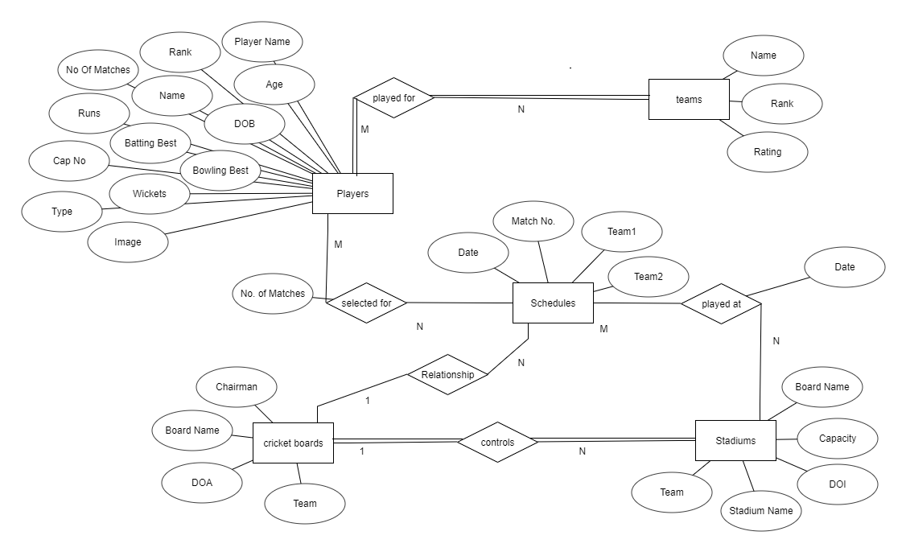

Figure 3.2: ER-Diagram.

**3.5 Output Design**

Designing computer output should proceed in an organized, well throughout manner; the right output element is designed so that people will find the system whether or executed. When we design an output, we must identify the specific output that is needed to meet the system. The usefulness of the new system is evaluated on the basis of their output. Once the output requirements are determined, the system designer can decide what to include in the system and how to structure it so that require output can be produced. For the proposed software, it is necessary that the output reports be compatible in format with the existing reports. The output must be concerned to the overall performance and the system’s working, as it should. It consists of developing specifications and procedures for data preparation, those steps necessary to put the inputs and the desired output, i.e. maximum user friendly. Proper messages and appropriate directions can control errors committed by users. The output design is the key to the success of any system. Output is the key between the user and the sensor. The output must be concerned to the system’s working, as it should. Output design consists of displaying specifications and procedures as data presentation. User never left with the confusion as to what is happening without appropriate error and acknowledges message being received. Even an unknown person can operate the system without knowing anything about the system.

This project has mainly four views which displays the details for

* Schedules
* Rankings
* Stadiums
* Cricket Boards
* Player Information

**Chapter 4**

**System Implementation**

**4.1 Implementation**

Implementation is the stage in the project where the theoretical design is turned into a working system and is giving confidence on the new system for the users that it will work efficiently and effectively. It involves careful planning, investigation of the current system and its constraints on implementation, design of methods to achieve the changeover, an evaluation of change over methods. Implementation is the most important phase. The most critical stage in achieving a successful new system is giving the users confidence that the new system will work and be effective. Any system developed should be secured and protected against possible hazards. Security measures are provided to prevent unauthorized access of the database at various levels. Password protection and simple procedures to prevent the unauthorized access are provided to the users. The system allows the user to enter the system only through proper user name and password.

* 1. **Create a connection to a database**

Before you can access data in a database, you must create a connection to the database. In PHP, this is done with the getConnection() function.

<?php

$con=mysqli_connect("localhost","root","","cricket");

?>

**4.3 Closing a Connection**

The connection will be closed automatically when the script ends. To close the connection before, use the close() function:

<?php

mysqli_close($con);

?>

**4.4 Triggers and Stored procedures**

* Triggers are the user defied constraints which will be checked before insertion or updating.
* The trigger used here updates the DOI of stadium automatically.
* Stored procedures are like functions in C or java, it performs specific instructions like calculating, updating and storing automatically into the database.
* In this project the stored procedure retrieves all values of stadium.

**4.4.1 Stored Procedure**

DELIMITER $$

CREATE DEFINER=`root`@`localhost` PROCEDURE `stadium`()

NO SQL

select * from stadiums$$

DELIMITER;

**4.4.2 Trigger**

CREATE TRIGGER `default_date`

BEFORE INSERT ON `stadiums`

FOR EACH ROW

set new.DOI=CURRENT_DATE();

CREATE TRIGGER `update` BEFORE UPDATE ON `player`

FOR EACH ROW BEGIN

IF (new.runs<old.runs) THEN SET new.runs=old.runs;

IF (new.wickets<old.wickets) THEN SET new.wickets=old.wickets;

END IF;

IF (new.no_of_matches<old.no_of_matches) THEN SET new.no_of_matches=old.no_of_matches;

END IF;

END IF;

END

**4.5 Result**

The resulting system is able to:

* Authenticate user credentials during login.
* Allows user to quickly and easily look for details of particular required data.
* The user can see the details required.
* Gives accurate information as updated by the admin.

**Chapter 5**

**Snapshots**

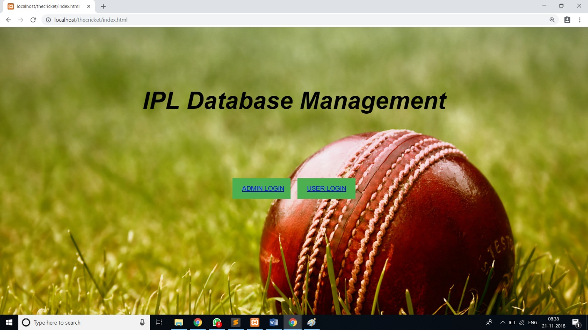Figure 6.1 Home page

In the above Figure 6.1, It shows Home Page which allows to login as admin and also as a user.

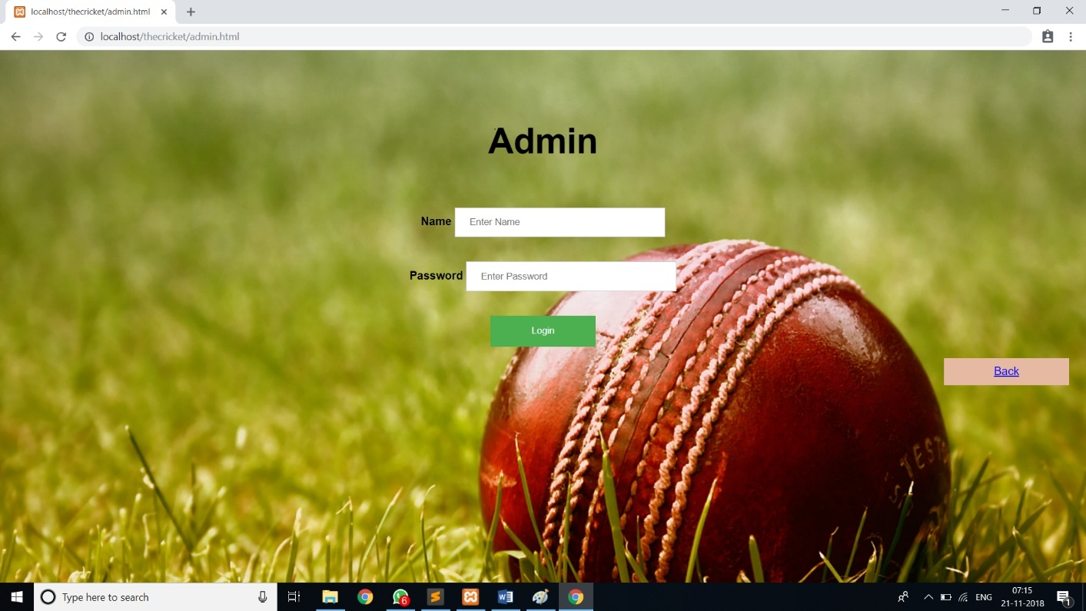

Figure 6.2 Admin Login Page

In the above Figure 6.2, It shows admin login page which gives authentication to enter into the Admin page.

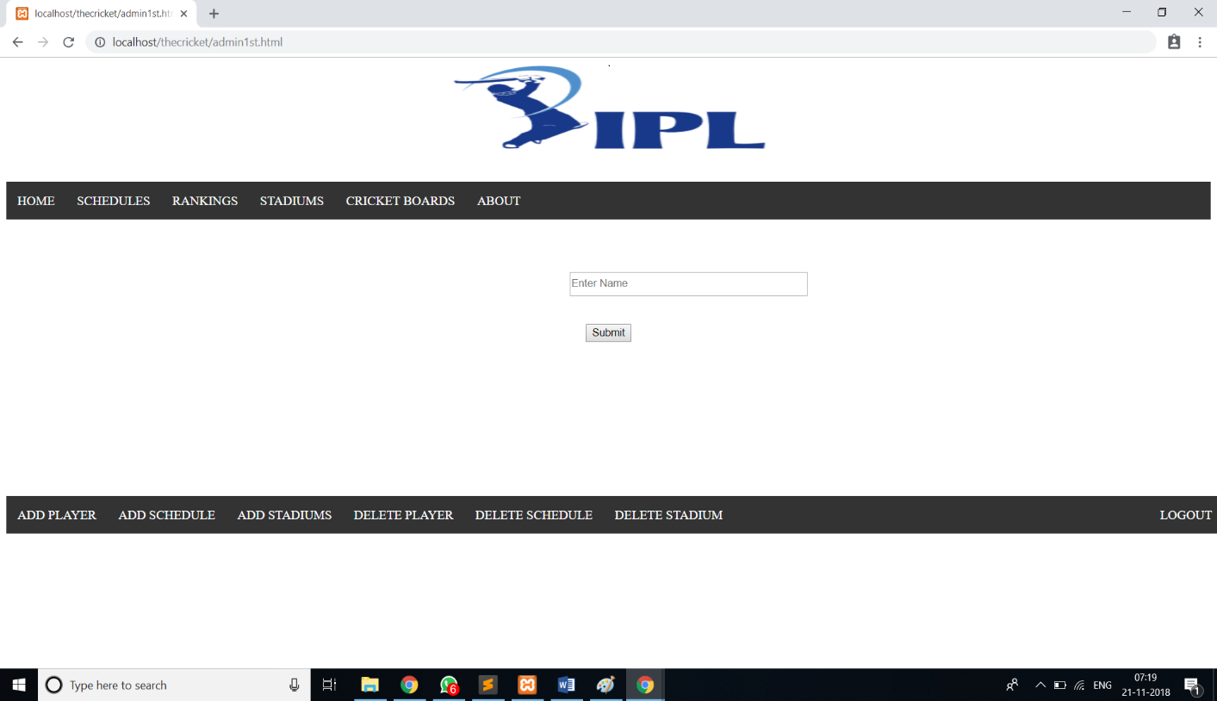

Figure 6.3 Admin’s Home Page

In the above Figure 6.3, shows window which allows to add and delete of players, stadiums, schedules and can view schedules, rankings, stadiums, cricket boards and about page.

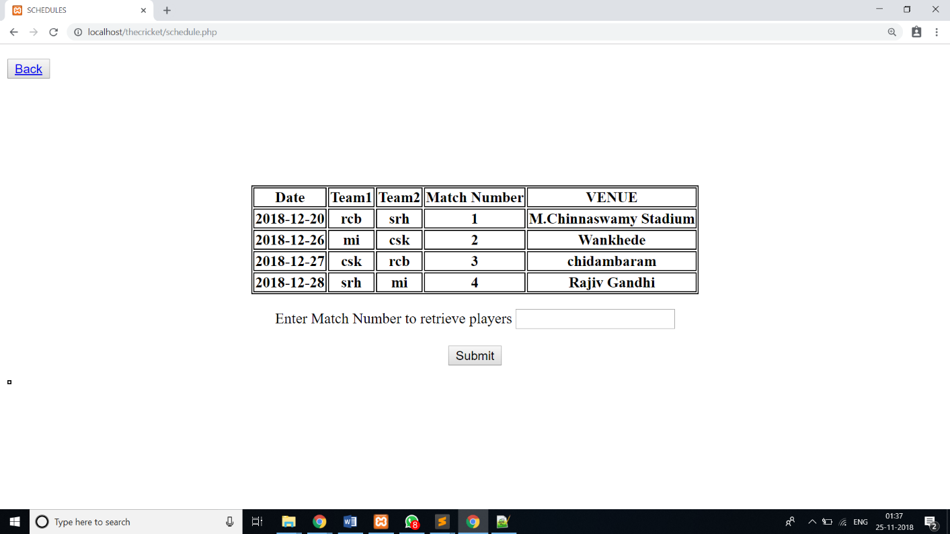

Figure 6.4 Schedules details

In the above Figure 6.4, It shows columns that Schedules details of all matches that are present in the database and also search button for players who are playing that match.

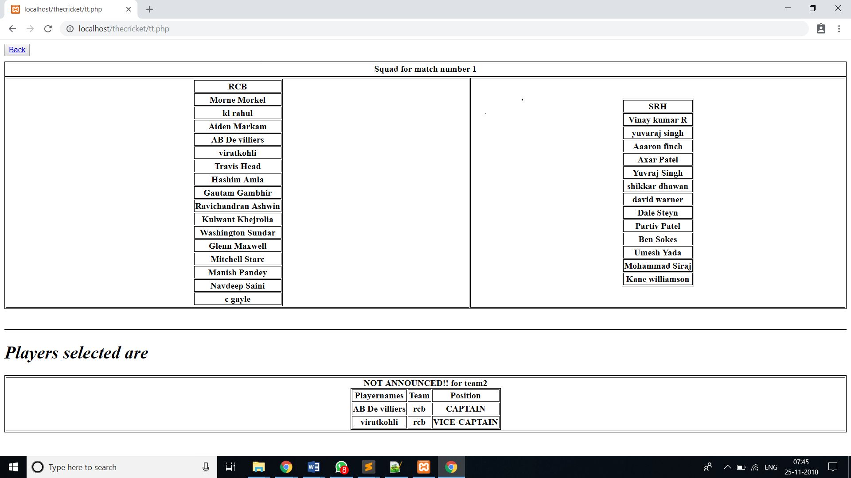Figure 6.5 Schedules details

In the above Figure 6.5, It shows columns that Shows squad available and players who got selected.

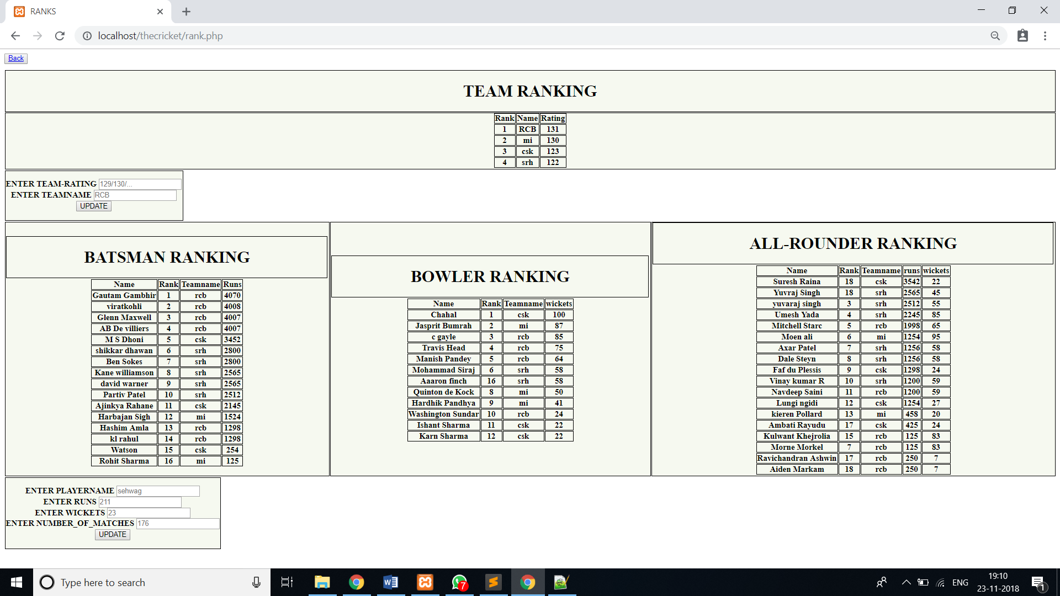Figure 6.6 Rankings

In the above Figure 6.6, It shows the window where updation of rankings available fpr team and also for players by updating runs, wickets it shows their ranks in the table.

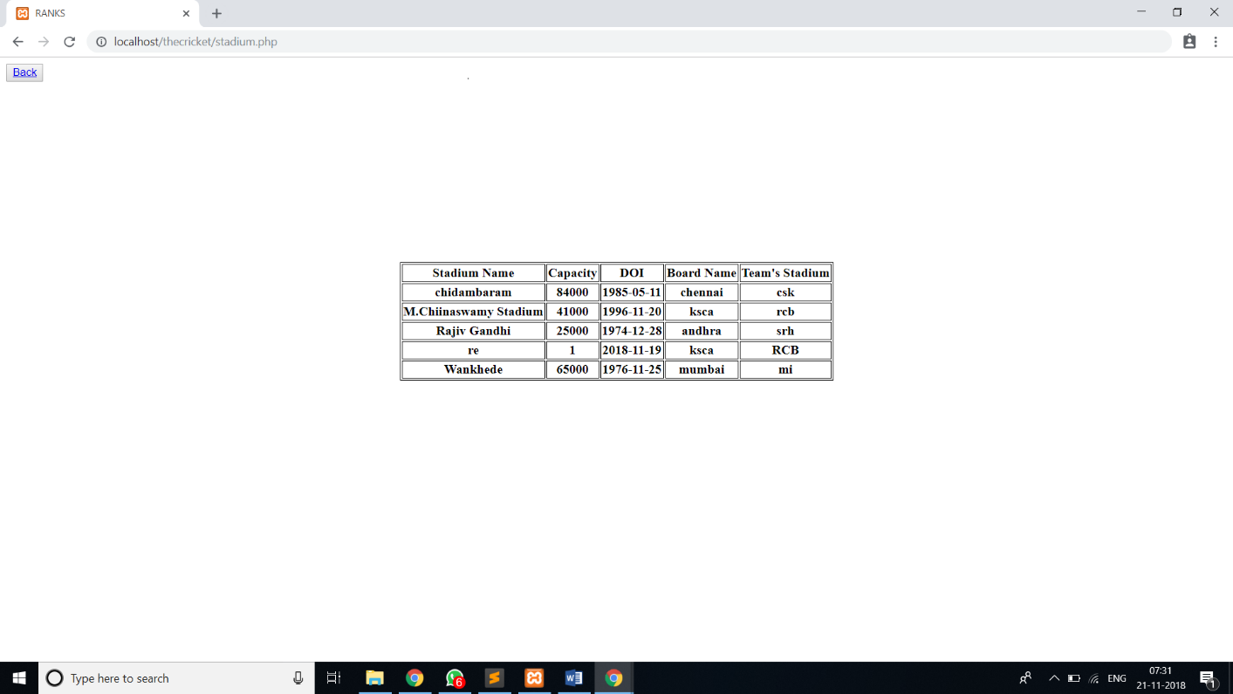Figure 6.7 Stadium Details

In the above Figure 6.7, Window shows updated Stadium details.

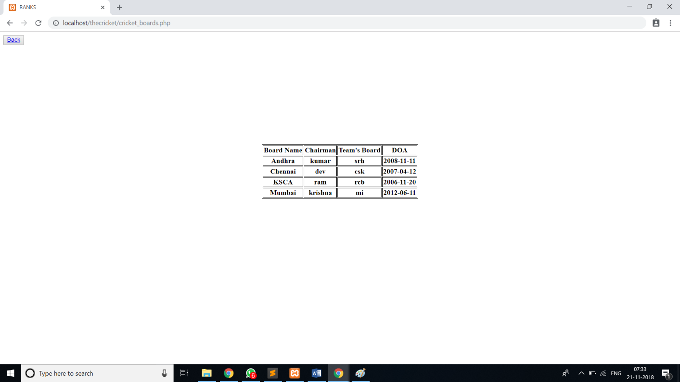

Figure 6.8 cricket boards information

In the above Figure 6.8, Window displays information about cricket boards like their name, their chairman with which team’s board and date of inauguration.

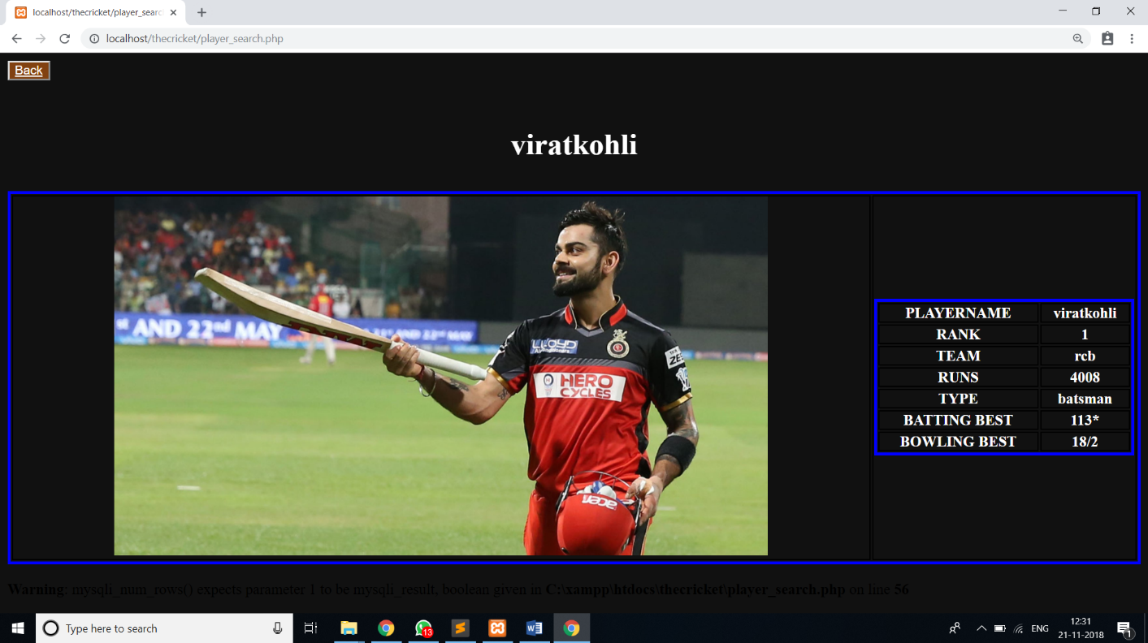Figure 6.9 Player search

In the above Figure 6.9, It shows the window where we get Player search details.

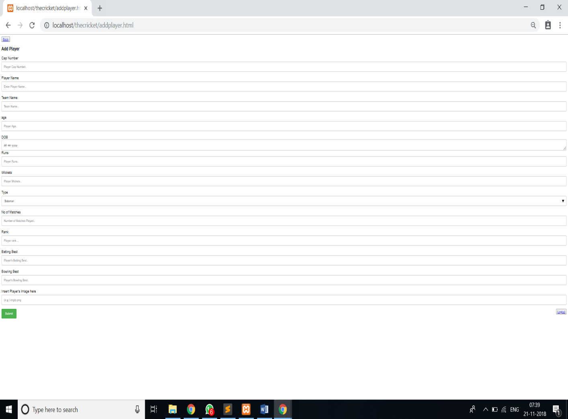

Figure 6.10 Add player

In the above Figure 6.10, It shows window which allows admin to add player by his bio-data like cap number, player name, team name, age, DOB, runs, wickets, type, Number of matches played, rank, batting best, bowling best and his image.

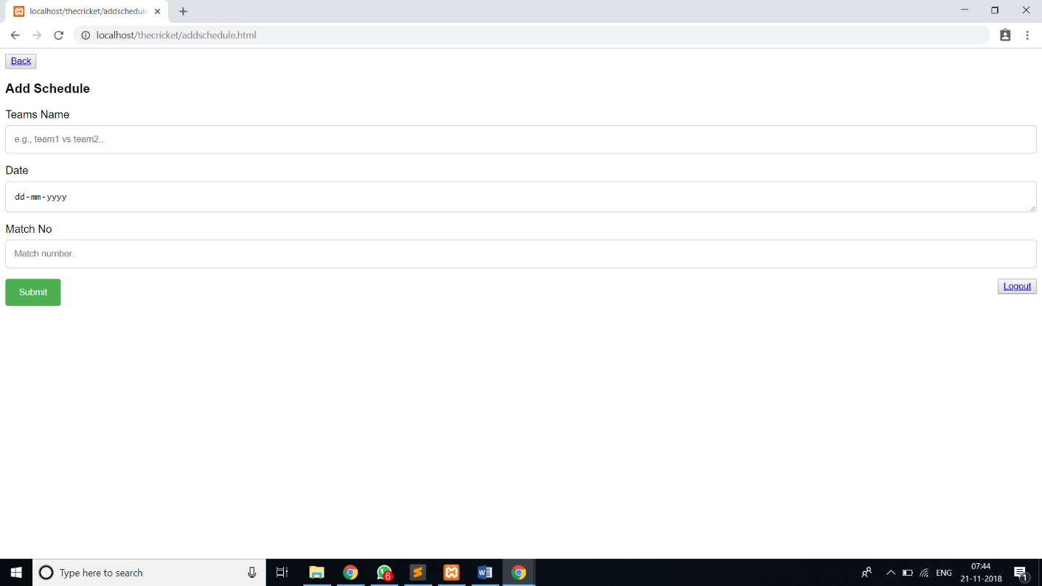Figure 6.11 Add schedule

In the above Figure 6.11, it shows window which allows admin to Add schedules for the matches in future by the team name, date and match number.

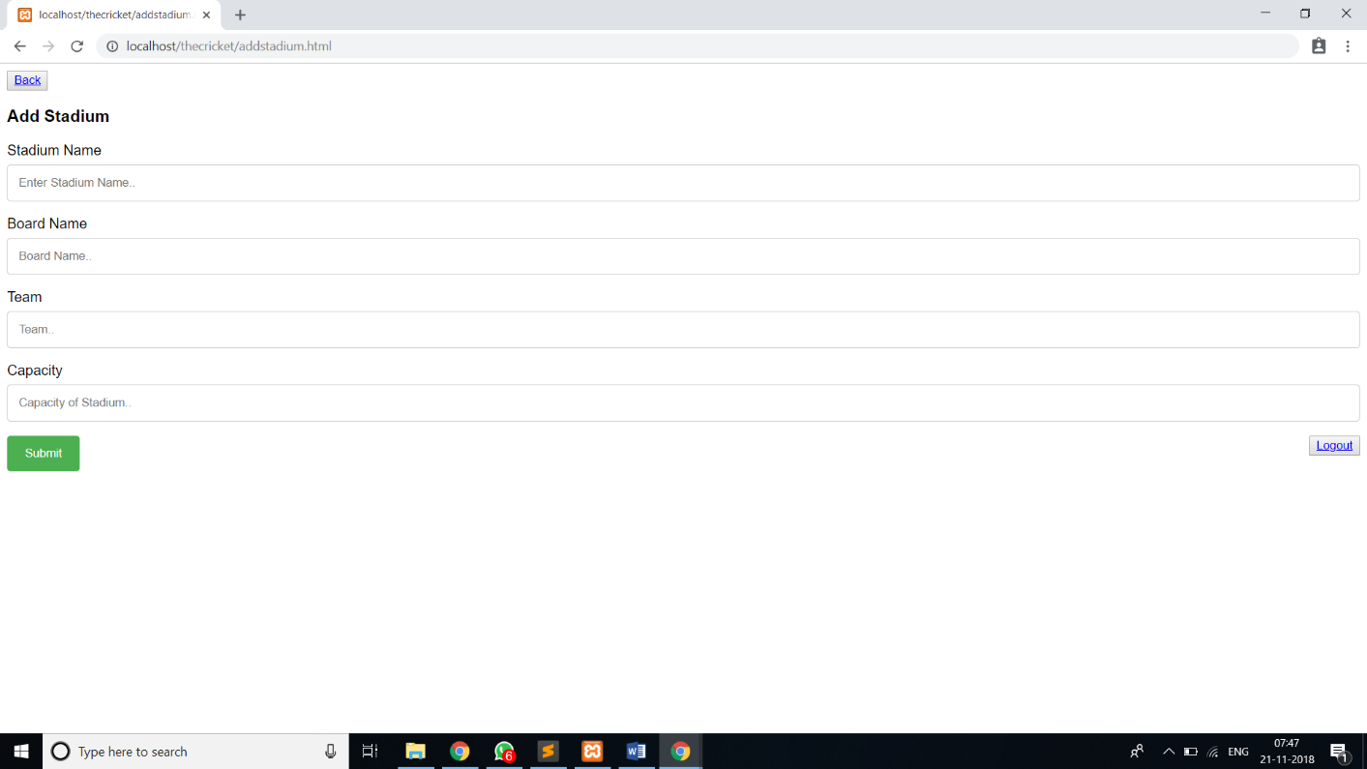

Figure 6.12 Add Stadium

In the above Figure 6.12, It shows window which allows admin to add stadium with stadium name, board name, team and Capacity.

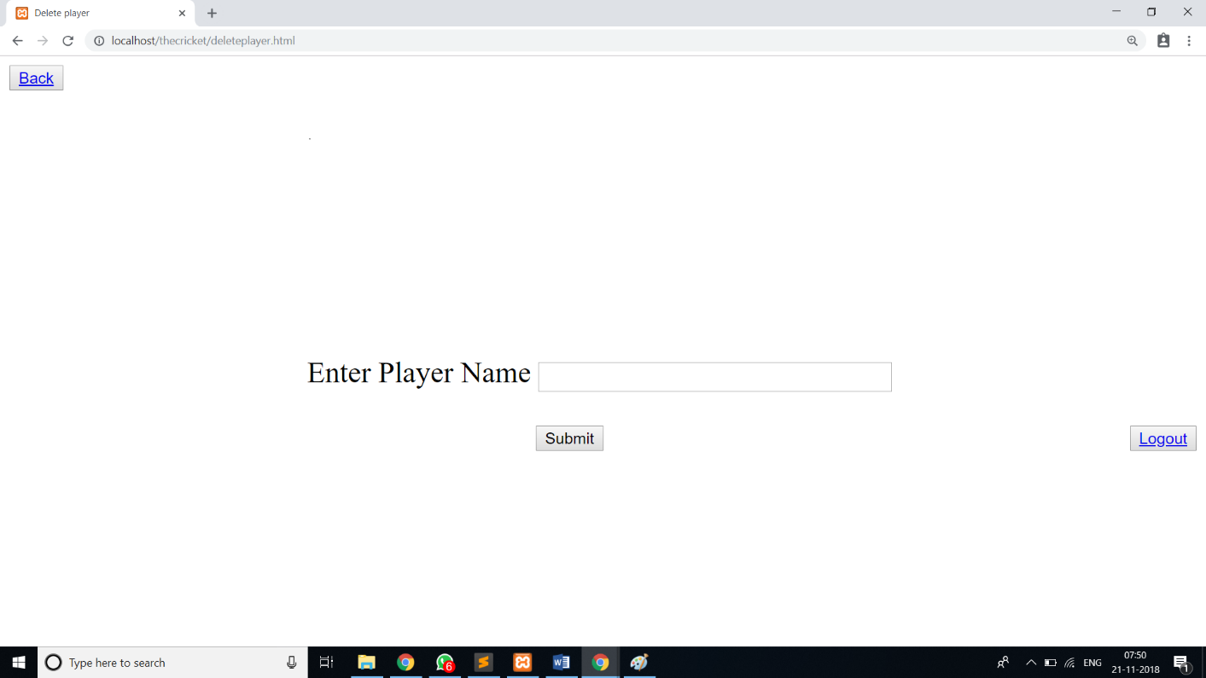Figure 6.13 Delete player

In the above Figure 6.13, it shows window which allows admin to delete a player by his name.

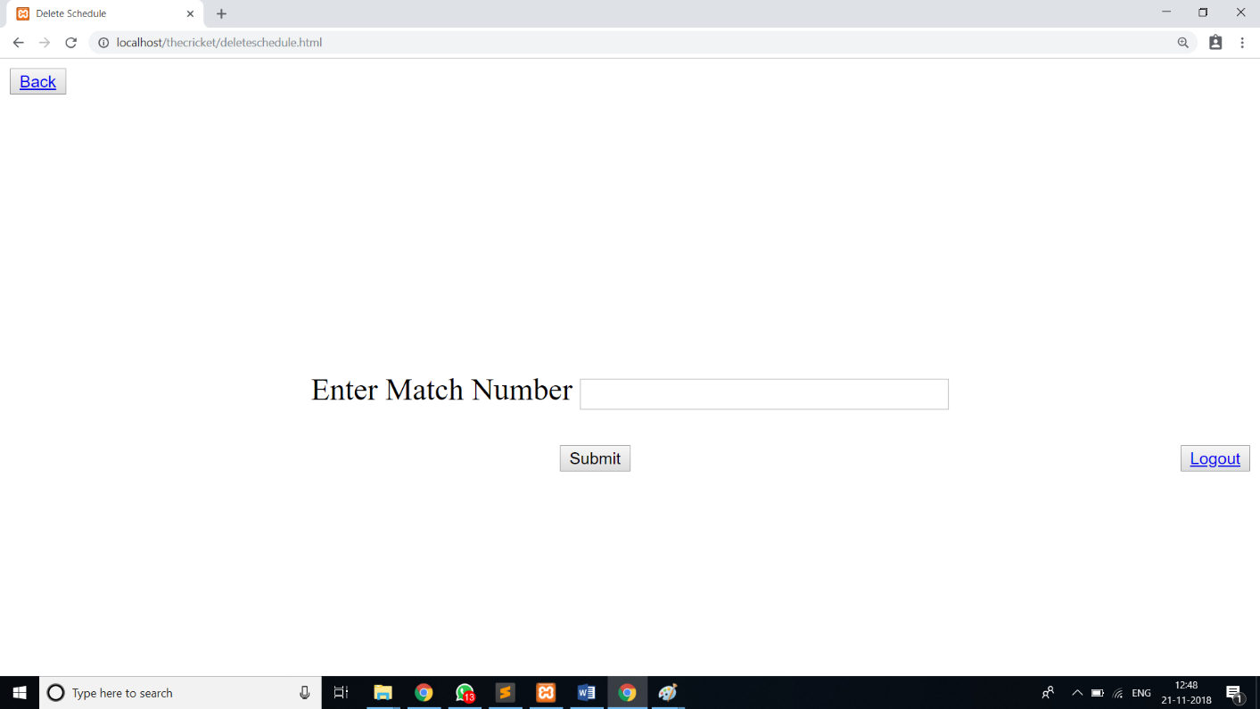

Figure 6.14 Delete schedule

In the above Figure 6.14, it shows window which allows admin to Delete a schedule by its match number.

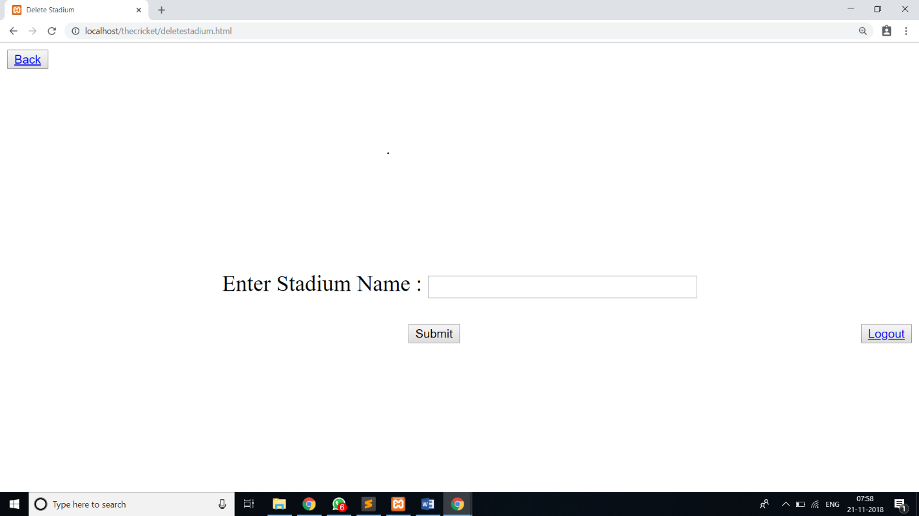Figure 6.15 Delete Stadium

In the above Figure 6.15, it shows window which allows admin to Delete stadium by its name

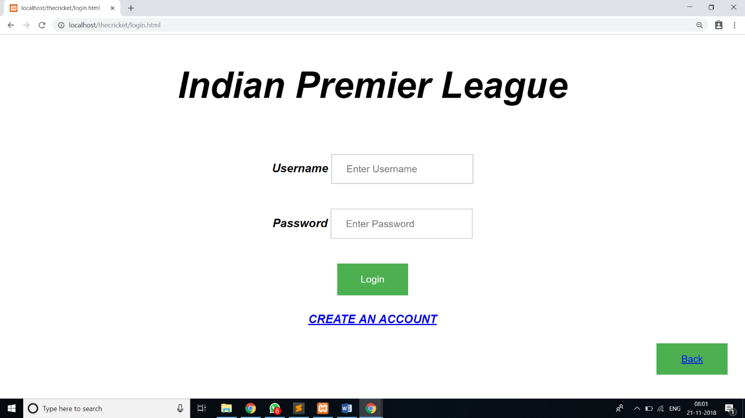

Figure 6.16 User login page

In the above Figure 6.16, It shows window which allows user to authenticate into user’s login page.

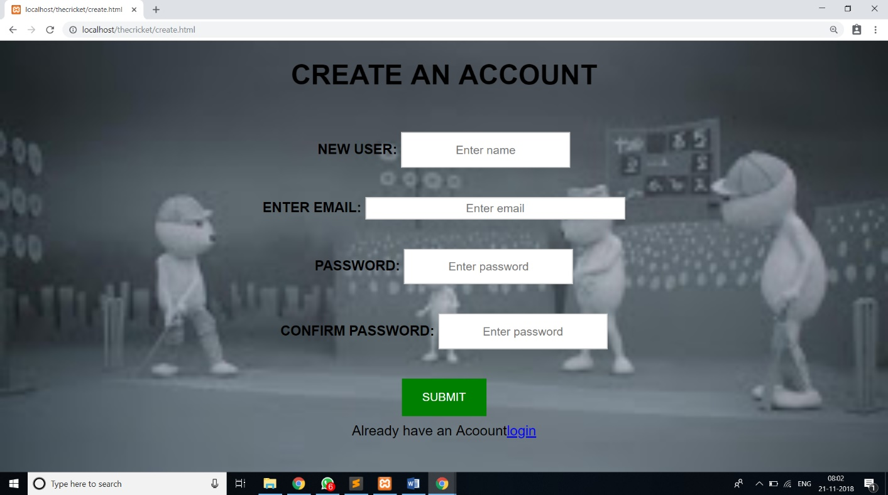Figure 6.17 create an account page

In the above Figure 6.17, it shows window which allows new users to Create an account.

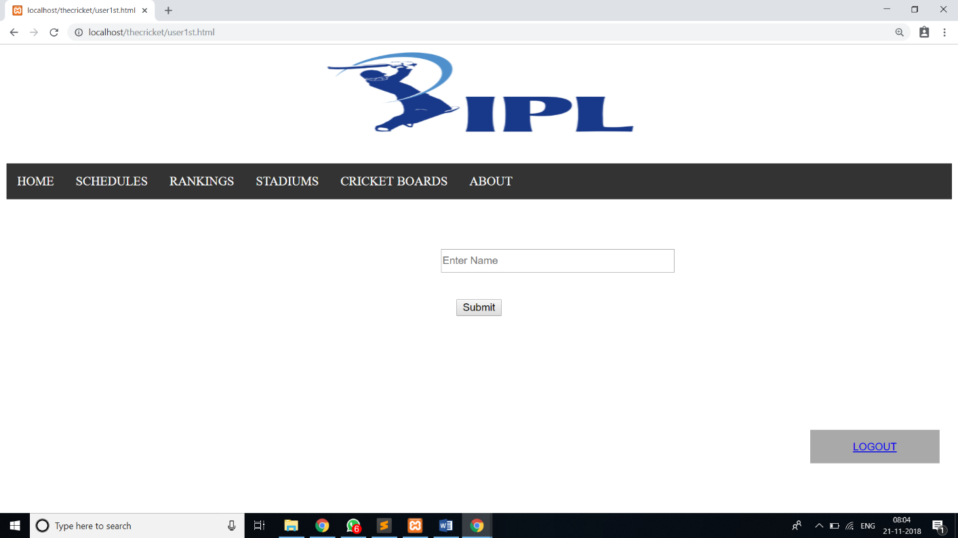

Figure 6.18 Home page for users

In the above Figure 6.18, It shows window shows Home page for users and it contains to search player’s information, schedules, rankings, stadiums, cricket boards and about IPL.

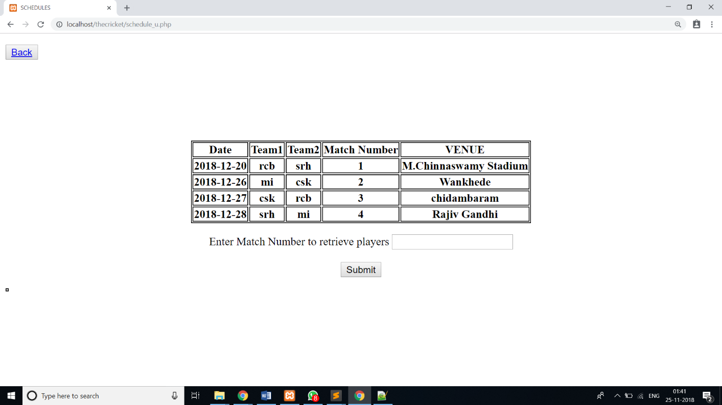Figure 6.19 schedules

In the above Figure 6.19, it shows window which gives information about schedules of future matches.

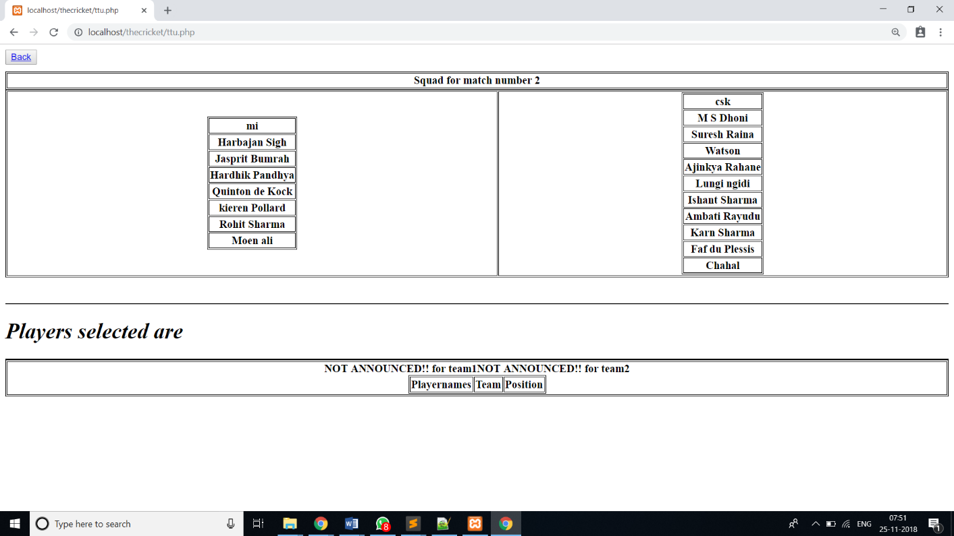

Figure 6.20 Schedules details

In the above Figure 6.20, It shows columns that Shows squad available and players who got selected.

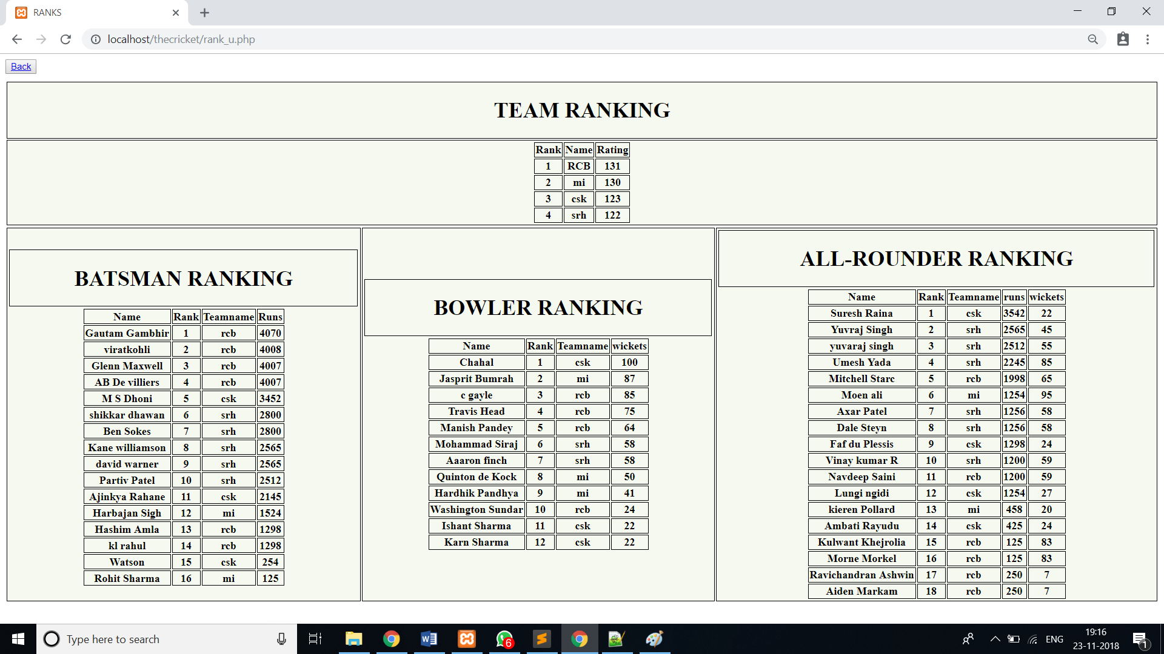Figure 6.21 Rankings

In the above Figure 6.21, it shows window that consists of team rankings and player rankings.

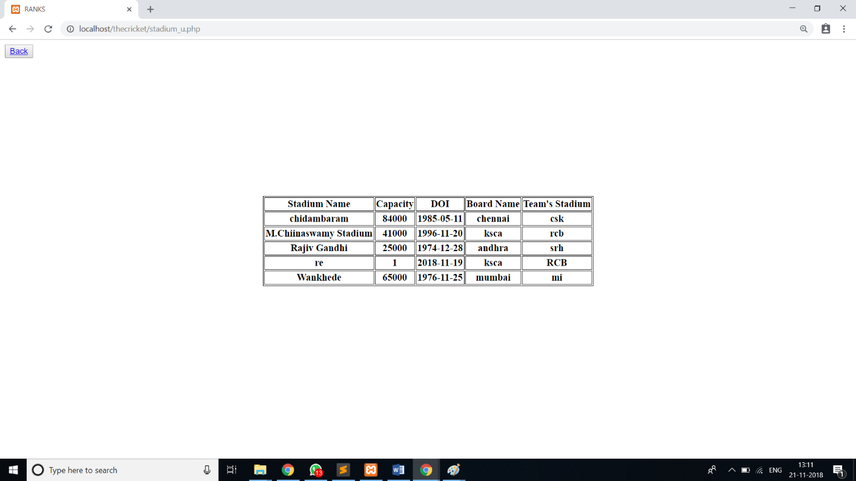

Figure 6.22 Stadium details

In the above Figure 6.22, it shows window gives details about Stadiums.

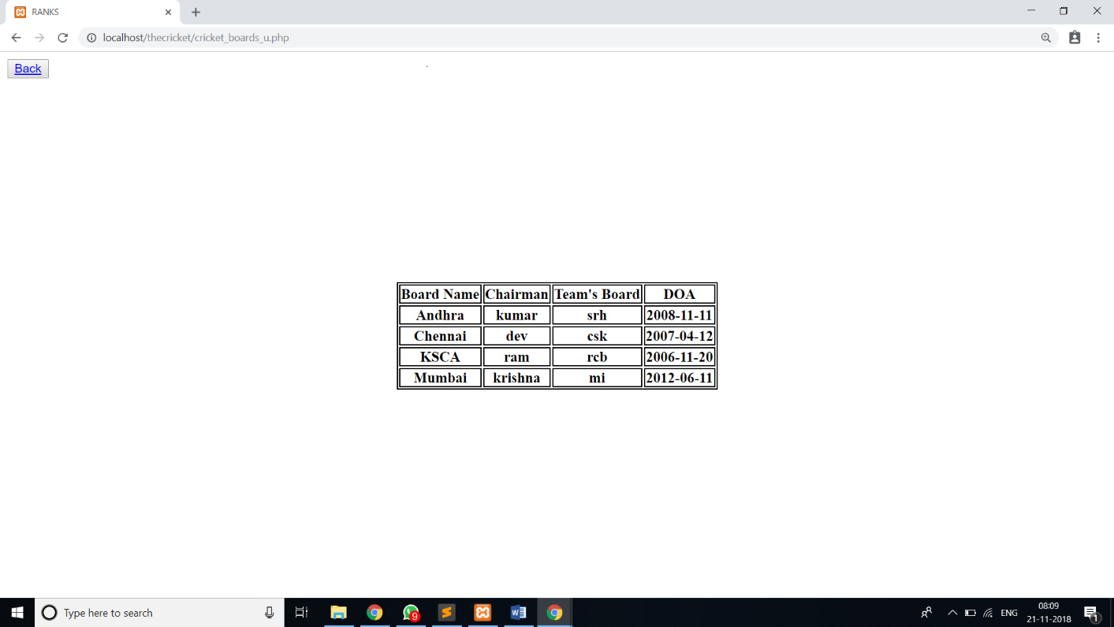

Figure 6.23 Cricket boards

In the above Figure 6.23, it shows window which gives information about Cricket boards.

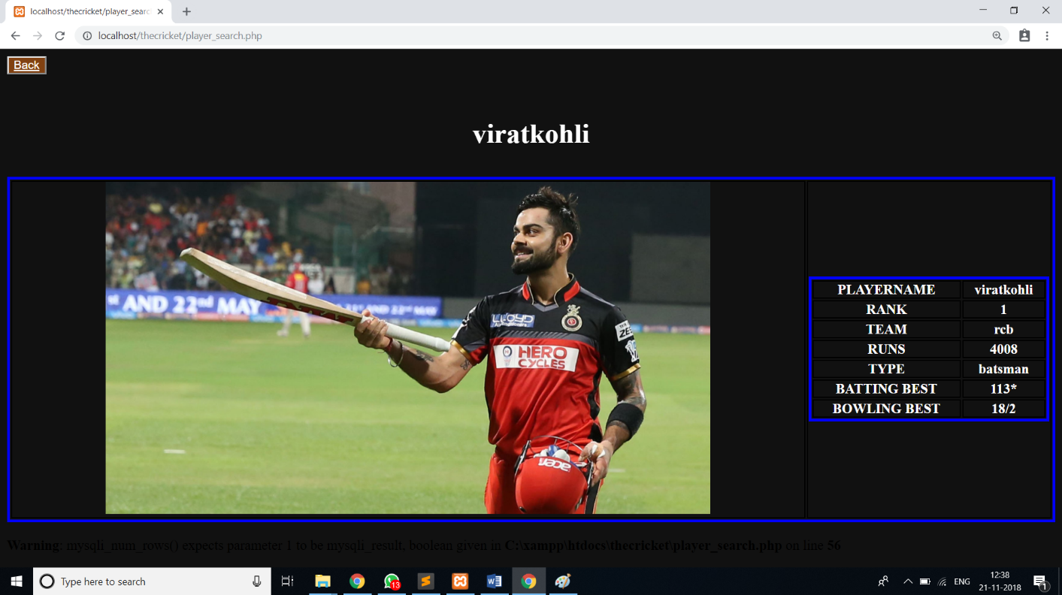 Figure 6.22 Player search for users

In the above Figure 6.22, It shows the window where users can get Player details by searching the name.

**Conclusion**

The project, developed using PHP and MySQL is based on the requirement specification of the user and the analysis of the existing system, with flexibility for future enhancement. The expanded functionality of today’s software requires an appropriate approach towards software development. This IPL database management software is designed for people who want to manage various particulars can be known by recording them in the database. various records and particulars about match got increased rapidly. Thereby the numbers of matches and there is going to be increased day-by-day. And hence there is a lot of strain on the person who are watching the IPL to know about future matches and also to see the records done by various players and getting datils in fingertips. Identification of the drawbacks of the existing system leads to the designing of computerized system that will be compatible to the existing system with the system which is more user friendly and more GUI oriented.

**Future Enhancements**

The current project is just based on taking the information and storing in respective data tables and representing the information in the different required forms and has the ability to search using the attribute. There are some enhancements which can be implemented further. They are as follows:

* Module that automatically gives the information about various cricket boards, stadiums and also rankings of various IPL teams and players by selecting or entering the relevant required item.
* Module that gives information about completely filled and partially filled information on various particulars.
* Can create module such that the user can login and gain information through the window.
* Make this project to the scope for players also.

**References**

[1] Ramez Elmasri and Shamkant B. Navathe, “Database systems Models, Languages, Design and Application Programming”,6th Edition, Pearson,2017.

[2] Ramakrishnan and Gehrke, “Database management systems”, 3rd Edition McGraw Hill2014

[3] Silberschatz Korth and Sudharshan, “Database System Concepts”, 6th Edition Mc-Graw Hill, 2013.

[4] Coronel, Morris,and Rob “Database Principles Fundamentals of Design, Implementation and Management” Cengage Learning 2012

[5] Abraham Silberchatz, Henry korth and S.Sudarshan, “Database System Concepts”, McGraw-Hill Education, 16 Jun 2010.

[6] Jeffery D.Ullman, “Principles of Data Base System”,Financial Times Prentice Hall 2nd Revised edition(1 December 1982).

[7] [http://stackoverflow.com](http://stackoverflow.com/)

[8] <https://www.w3schools.com>

[9] <http://www.phptpoint.com>

[10] <https://www.bootply.com/>

[11] <https://www.tutorialspoint.com>

[12] <http://1000projects.org/>

[13] <https://erdplus.com/#/>